Asset | Alt Text
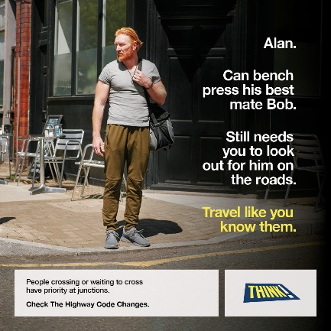 | "Alan. Can bench press his best mate Bob. Still needs you to look out for him on the roads. Travel like you know them.  People crossing or waiting to cross have priority at junctions.  Check The Highway Code Changes. THINK!"  An image showing a male pedestrian checking the road while waiting to cross. The man looks visibly strong.
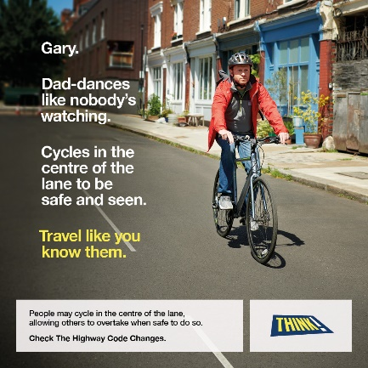 | "Gary. Dad-dances like nobody's watching. Cycles in the centre of the lane to be safe and seen. Travel like you know them.  People may cycle in the centre of the lane, allowing others to overtake when safe to do so.  Check The Highway Code Changes. THINK!"  An image showing a man on a bike with a red jacket and black helmet, riding down a quiet street in the centre of the lane.
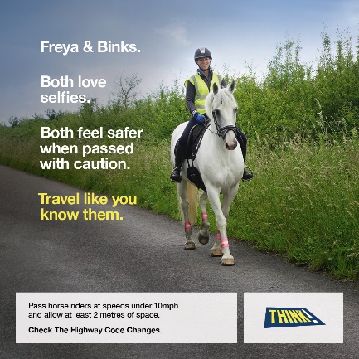 | "Freya & Binks. Both love selfies. Both feel safer when passed with caution. Travel like you know them.  Pass horse riders at speeds under 10mph and allow at least 2 metres of space.  Check The Highway Code Changes. THINK!"  An image showing a woman wearing high vis coat and a helmet, riding a grey horse, on the side of a country road. The horse is wearing high vis leg bands.

