Asset | English Alt Text | Welsh Alt Text
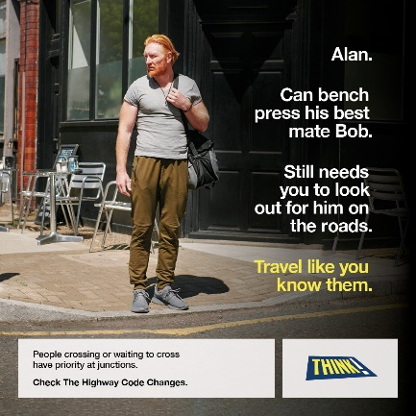 | "Alan. Can bench press his best mate Bob. Still needs you to look out for him on the roads. Travel like you know them.  People crossing or waiting to cross have priority at junctions.  Check The Highway Code Changes. THINK!"  An image showing a male pedestrian checking the road while waiting to cross. The man looks visibly strong. | " Alan. Gall godi ei fêt gorau Bob fel pwysau ar y fainc. Ond mae dal angen ichi edrych allan amdano ar y ff ordd. Teithiwch fel tasech chi’n eu nabod nhw.  Dylid rhoi blaenoriaeth i bobl sy’n croesi neu’n aros i groesi wrth gyff yrdd.  Darllenwch y newidiadau i Reolau’r Ffordd Fawr."  Delwedd o gerddwr yn cadw golwg ar y ffordd wrth aros i groesi. Mae’r dyn yn edrych yn gryf.
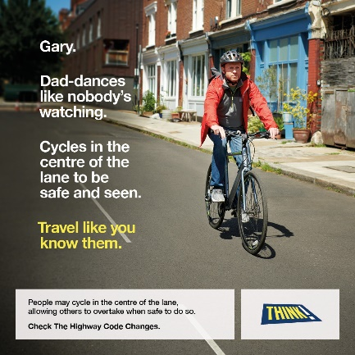 | "Gary. Dad-dances like nobody's watching. Cycles in the centre of the lane to be safe and seen. Travel like you know them.  People may cycle in the centre of the lane, allowing others to overtake when safe to do so.  Check The Highway Code Changes. THINK!"  An image showing a man on a bike with a red jacket and black helmet, riding down a quiet street in the centre of the lane. | "Gary. Dawnsio disgo fel petai neb yn edrych. Ac yn seiclo ar ganol y lôn I gael ei weld a bod yn ddiogel. Teithiwch fel tasech chi'n eu nabod nhw.  Gall pobl seiclo yng nghanol y lôn, gan adael eraill i basio pan fo'n ddiogel.  Darllenwch y newidiadau i Reolau’r Ffordd Fawr."  Delwedd o ddyn ar gefn beic yn gwisgo siaced goch a helmed ddu, yn seiclo i lawr stryd dawel ar ganol y lôn.
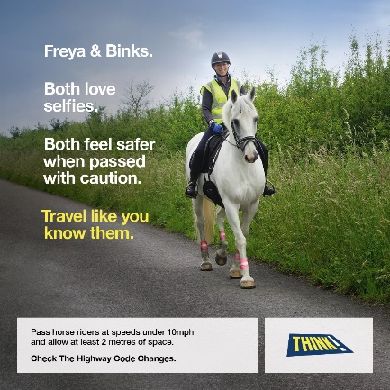 | "Freya & Binks. Both love selfies. Both feel safer when passed with caution. Travel like you know them.  Pass horse riders at speeds under 10mph and allow at least 2 metres of space.  Check The Highway Code Changes. THINK!"  An image showing a woman wearing high vis coat and a helmet, riding a grey horse, on the side of a country road. The horse is wearing high vis leg bands. | "Freya a Binks. Mae'r ddau'n caru selffis. Ac yn teimlo'n fwy diogel pan mae pobl yn ofalus wrth basio. Teithiwch fel tasech chi'n eu nabod nhw.  Pasiwch bobl ar gefn ceffyl ar gyflymder o 10mya a gadewch o leia' 2 metr iddynt.  Darllenwch y newidiadau i Reolau’r Ffordd Fawr."  Delwedd o wraig yn gwisgo cot a helmed lachar, ar gefn ceffyl llwyd, ar ochr ffordd wledig. Mae bandiau llachar ar goesau’r ceffyl.

